PHASE 1
Project Specification Document

Midstream College Quiz Night

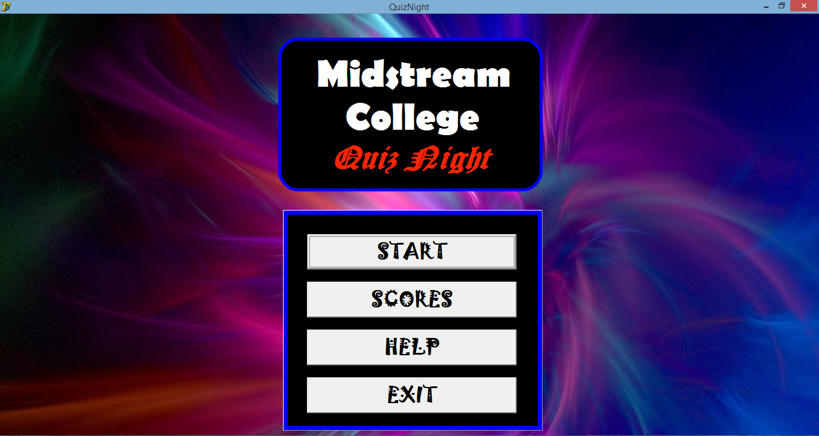

Developed by Bill Guo

Signoffs
Phase | Teacher | Date | Signature
1) Project Specification | Mrs. Niebuhr
Table of Contents
1. Summary 3
2. Project Goals, Justification, and Success Criteria 3
2.1 Project Goals 3
2.2 Justification 3
2.3 Success Criteria 3
3. Features of the program 4
3.1. Specifications of Program Functions 4
3.2. Specifications of User Interface 4
3.3. Specifications of Help 4
3.4. Specifications of Data Storage 4
4. Security Requirements 5
5. Data Conversion Requirements 5
6. Performance and Response Time Requirements 5
7. Hardware, Software and Installation Requirements 5
8. Localization Requirements 6
9. Testing Requirements 6
10. Data Archival, Backup and Recovery Requirements 6
11. Reporting Requirements 7

1. Summary
“Quiz Night” is an event held at Midstream College twice every year: one usually in the first term and another in one of the three following terms. The Academic Committee hosts it and has one of the IT students make a program for them to keep the event running. In the past few years, the programs developed to run this event has only been programs to keep track of the scores of the houses and have been mediocre. No actual program has been developed to run this event. In order to make this event a big sensational tradition, the program “Quiz Night” is going to be created. This program will help host and control this academic event annually for the whole duration of the event.

2. Project Goals, Justification, and Success Criteria
2.1 Project Goals | 2.2 Justification
Program that actually runs the Quiz Night. | Spectators will be able to follow and enjoy.
All grades and teachers can participate. | Event will be successful and program will be accepted.
Sufficient help guidelines. | So that this program can be used forever.
Good performance and efficiency. | Event runs smoothly and fast.
User-friendly interface and messages. | Program easy to use and logical.
Accurate and can keep track of data. | Can be taken legitimately and be trusted.
Have good defensive programming. | Room for very little errors.

2.3 Success Criteria
The program will be a success if it can:
- Get the correct participants partaking for the correct grade.
- Retrieve the correct questions and answers for the particular grade to ask and give.
- Keep track of the house scores when a quiz is running.
- Give the final overall score of which house won the quiz night.
- Let the audience keep track of what is going on.
- Let the audience know the question and the answer to it.
- Have a timer so that participants cannot take too long to answer.
- Be fair and realistic in who pressed the buzzer first and who was second.
- Keep records of each grades quiz night.
- Accommodate the teachers for quiz night.
- Run smoothly and have no glitches when quiz is running.
- Have good programming so that no errors are encountered.
- When errors are encountered, it can be solved through resetting everything.

3. Features of the program

3.1. Specifications of Program Functions
The program will be able to do the following:
- Get the participants of the particular grade doing the quiz night.
- Display the participants in their houses.
- Keep track of the houses score.
- Identify which house clicked the buzzer first and thereafter second.
- Retrieve the correct questions for the correct grade.
- Retrieve the correct answers for the correct grade.
- Have the correct subject headings every 5 questions.
- Have a timer.
- User can decide if answer is correct or wrong.
- Reset if a score is wrongly given.
- Identify the overall house winner at the end.
- Have a separate teachers interface since there are more teachers in a team.

3.2. Specifications of User Interface
The user-interface will have the following:
- Front Cover will be for the cover for the event to begin.
- Grade Menu is to assign which grade’s turn is it or the teacher’s turn.
- Score sheet is to display the houses participants and their scores.
- Question is used to display the questions and answers with a timer.
- Number is used to get participants ready for the next question.
- Teachers is the teachers score sheet to accommodate them.
- Scores is to identify the overall house winner for the event.
- Help is to give help guidelines on how to use the program.

3.3. Specifications of Help
The following help features will be available:
- A manual on how to go about with the program.
- A help form to see the guidelines on how to use the program.
- A help textfile if program cannot be run.
- Defensive programming so that programming will be relatively easy to use.

3.4. Specifications of Data Storage
The following data storage will be available:
All data is stored in the form of textfiles which are stored in folders.
- The Answers Folder contains: Grade 8-12.txt and Teachers.txt files.
- The Questions Folder contains: Grade 8-12.txt and Teachers.txt files.
- The Participants Folder contains: Grade 8-12.txt and Teachers.txt files.
- The Scores Folder contains: Grade 8-12.txt and Teachers.txt files.
- The Final Folder contains: House.txt file and Help.txt file.

4. Security Requirements
- The whole program with its necessary files is stored in the Billabong folder in the C: drive on the Desktop or My Documents. The computer’s hardware and hard drive should cover the whole C: drive so that it is protected, frequently scanned, safe and accessible.

5. Data Conversion Requirements
Normal Data Conversions:
String to Integer : StrToInt – String to Integer
Integer to String: IntToStr – Integer to String
String to Float: StrToFLoat – String to FLoat
Float to String: FloatToStr – Float to String

6. Performance and Response Time Requirements
Performance:
The program will be very well programmed so that it has a good performance. It will never crash and will only close when told so. It will keep on running and have a good performance for the duration of the event.

Response Time:
With good programming, the programs response time will be top-notch and quick. There won’t be any lag and the program and event will run smoothly. Buzzers will work and the program will be able to identify which buzzer was first without disregarding the other buzzers.

The program has good graphics with good programming. The only requirement needed is a CPU that can work and a graphics card that can view basic graphics – a laptop’s graphics card can work.

7. Hardware, Software and Installation Requirements
Screen Size
- A minimum of 1024x600
Operating Systems
- Windows XP SP3 and newer
- Mac OSX 10.6 and newer
- Linux - chromeOS
Computer Speed and Processor
- 1GB of RAM
- 2GHz processor
- Use a computer 5 years old or newer
Internet Speed
- Minimum speed of 512kbps
Software needed:
- Notepad/Notepad++

8. Localization Requirements
Language must be set to English(ENG).
Country must be set to South Africa to use the currency – Rand.

9. Testing Requirements
Testing should ensure that:
- The correct participants’ names are shown.
- The quiz’s score is kept track of.
- The correct questions and answers are shown for the correct grade.
- Teachers are accommodated.
- Timer is running.
- Buzzers are working.
- Correct and Wrong colour buttons are working.
- Correct arrows are pointed indicating which teams should answer.
- The overall house winner can be determined.
- All data is saved and recorded at the end.
- Help file and help interface exists and is accessible.
- Program can exit with no memory leaks or errors.
- Event can be successfully run.
- Audience can partake in the event and know constantly what is going on.

10. Data Archival, Backup and Recovery Requirements
All files in the Billabong folder must be backed up.
The Billabong folder contains the following:
- The Answers Folder contains:
  - Grade 8.txt
  - Grade 9.txt
  - Grade 10.txt
  - Grade 11.txt
  - Grade 12.txt
  - Teachers.txt
- The Questions Folder contains:
  - Grade 8.txt
  - Grade 9.txt
  - Grade 10.txt
  - Grade 11.txt
  - Grade 12.txt
  - Teachers.txt
- The Participants Folder contains:
  - Grade 8.txt
  - Grade 9.txt
  - Grade 10.txt
  - Grade 11.txt
  - Grade 12.txt
  - Teachers.txt
- The Scores Folder contains:
  - Grade 8.txt
  - Grade 9.txt
  - Grade 10.txt
  - Grade 11.txt
  - Grade 12.txt
  - Teachers.txt
- The Final Folder contains:
  - House.txt
  - Help.txt
- The actual program QuizNight.exe
- The Delphi files of the program

All these files need to be backed up as they are needed to run the event. Just this one folder is needed. Just backup this folder when backing up your computer and these files and program will be retrievable and safe.

11. Reporting Requirements
Program is used to run an event, so no documentation is needed to be printed or generated. However, the only reporting that is needed to be done at the end of the event is to announce which house won the event, and that is calculated through using points. Therefore the program will not be using any reports.

